# Assignment 1: Charter, Scope, and Requirements Document

Project 1: API Development and Testing

University of British Columbia Okanagan

COSC499 - Summer 2022

Date: May 27, 2022

contacts:

## Wasi-ul-hassan Raza([wasmiester@gmail.com](mailto:wasmiester@gmail.com))

## Calvin Qu([Calvin000128@gmail.com](mailto:Calvin000128@gmail.com))

Po-Chia Wei([lunch33665566@gmail.com](mailto:lunch33665566@gmail.com))

Austin Wong(austinwong1@yahoo.ca)

1. **Project Objective 3**
2. **Stakeholder List 3**
3. **Major Milestones 3**
4. **Requirements 3**

**4.1 Functional Requirements 3**

**4.2 Non- Functional Requirements 4**

**4.3 Technical Requirements 4**

**4.4 User Requirements 4**

1. **Assumptions 4**
2. **High-Level Risks 5**
3. **Workflow and methodology 5**
4. **User Group and UML Diagram 5**

1. **Work Breakdown Structure 6,7,8**

**10.Approvals**

**1. Project Objective**

HelpYa is a trade service procurement app that is a platform that connects clients and businesses. Using the platform, customers will be able to purchase, search, and negotiate services with the business of their choosing. The client would like to design and develop a backend for an ios app for now with plans for cross-platform for android and web in the future. Our current goal is to have a database for user information log in and authentication and payment transaction

**2. Stakeholder List**

* Harrison Larson
* Thomas Pattison
* Bright Anorchie
* Scott Fazackerley (UBC)
* Project team

**3. Major Milestones**

1. Make a database to handle large user base and link it to the API (June 15)
2. Have a workable demo that can make purchases from client to seller (July 13)
3. Add fields like location or business owner to the API. System recovery feature. Possibly add more features depending on time (August 20)
4. QA all features and systems (August 25)

**4. Requirements**

**4.1 Functional Requirements**

* Encryption for user data ie credit cards
* Ensure the software is flexible for adding features and updating during downtime
* Admin suite for adding deleting and modifying account information
* Administrative tasks to add delete and modify user and client accounts and information
* outputs are in JSON so can be queried by the front end

**4.2 Non-Functional Requirements**

* One platform for both business and customer. When users open the app and try to make an account
* Have the system be able to easily recover and back up data in the system
* Ensure the software is cross-compatible and able to launch on different systems in the future.
* Have the software capable of supporting 1000 users

**4.3 Technical Requirement**

* Encryption of sensitive information like credit card info
* Use node js to ensure compatibility and ensure it is able to be used cross-platform in the future
* Authenticate encryption using SABS 256 encryption

**4.4 User Requirements**

* Username and password to log in
* Prompt the user if they are a business user or client user
* When creating an account, both the business user and client user will provide the required information, depending on the type of account they are creating
* A client receiving a service will be able to scroll through different services and seek any that peaks their interest
* A business user will be able to provide information on their business which includes, the name of their store and owners, phone number, email, the fee they charge, their education as well as their location; which will all be displayed on their business profile for clients to see

**5. Assumption**

* Every team member finishes their task on time
* Every team member have skills in certain coding languages
* Communication is open and effective
* All milestones are met
* The program delivers to the clients on time

**6. High-Level Risks**

* Team members drop the course
* Team members get sick and absent
* Lack of communication in the team
* Low morale in team
* Finishing coding in parts that can not combine in a whole
* Dependants are not finished
* Could not meet client’s requirements
* Lack luster work
* Lack of communication with clients

**7. Workflow and methodology**

We will discuss requirements, design solutions, code solutions, test solutions with clients, and get feedback from clients. Our team will use Kanban as our project workflow and we will have weekly meetings for the team. Every Thursday at 5:00 pm we will have a meeting with our clients. When adding a new feature the person creating the feature will fork from the love branchon GitHub. On completion, they will make a pull request which the integration manager will have a look at and push onto the main branch

**8. User Group and UML Diagram**

The target user group would be the companies or personal industries that are struggling to get more views and link popularity. The app will promote and advertise their names and descriptions throughout the mobile beauty market.

UML Diagram:

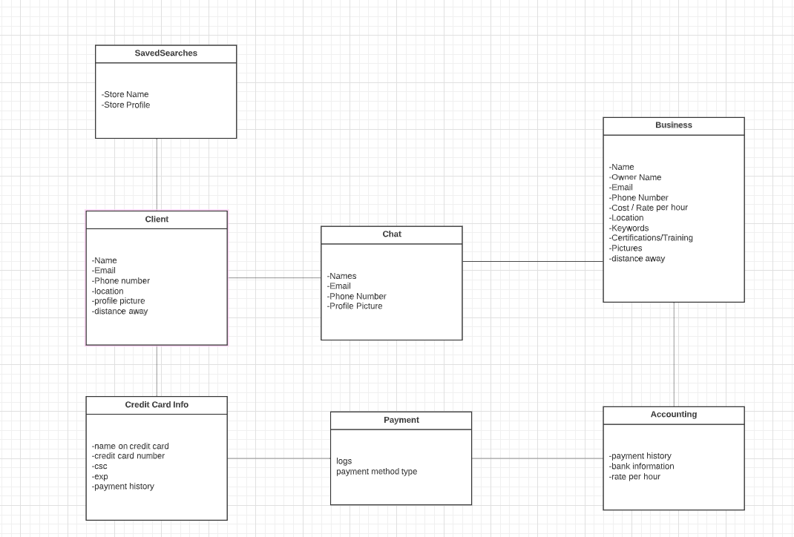

USE case diagram

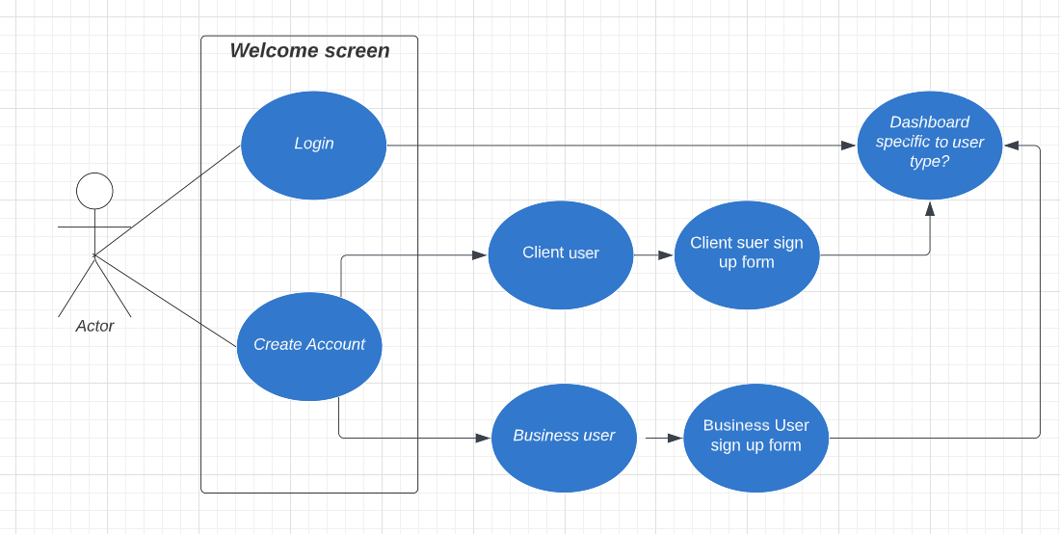

**9. Work Breakdown Structure**

| **Task List** | **Average Hours** | | | |
| --- | --- | --- | --- | --- |
|  | Wasi | Calvin | Pochia | Austin |
| **Functional Requirement** |  |  |  |  |
| **Database and back-end** | 2 |  |  | 4 |
| Initializing database with required tables and columns | 4 |  | 2 | 5 |
| Setting up the back-end starter code and choosing tech stack. | 2 |  | 2 |  |
| Making connections between back-end and database. | 3 |  | 2 | 3 |
| Adding and deleting feature | 2 |  | 2 | 3 |
| Data encryption. | 3 | 3 | 2 |  |
| **Meetings** |  |  |  |  |
| Client meeting weekly | 1 |  |  |  |
| Team meeting weekly | 3 | 3 | 3 | 3 |
| **Testing** |  |  |  |  |
| Front-end testing | 2 | 2 | 2 |  |
| Back-end testing | 2 | 2 | 2 | 2 |
| Integration testing | 1 | 1 | 1 | 1 |
| Usability tesing | 1 | 1 | 1 | 1 |
| **Documentation** |  |  |  |  |
| Scope and chartar document | 1 | 5 | 5 | 1 |
| Final report | 5 | 5 | 5 | 5 |
| Testing report | 2 | 2 | 2 | 2 |
| Peer evaluation Report | 2 | 2 | 2 | 2 |
| Readme file | 1 | 1 | 1 | 5 |

**10.Approval**

**Project Sponsor Signature __________________________________**

**Project Manager Signature __________________________________**